

Digital image processing

Lab 02



February 4, 2019

Muhammad roshan mughees

193590

Task 1:

**Code:**

import PIL

from PIL import Image

im = Image.open("tempimg.jpg")

print im.format, im.size, im.mode

im.show()

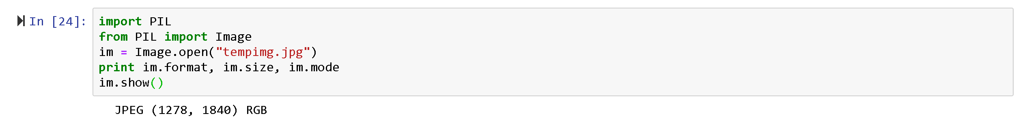

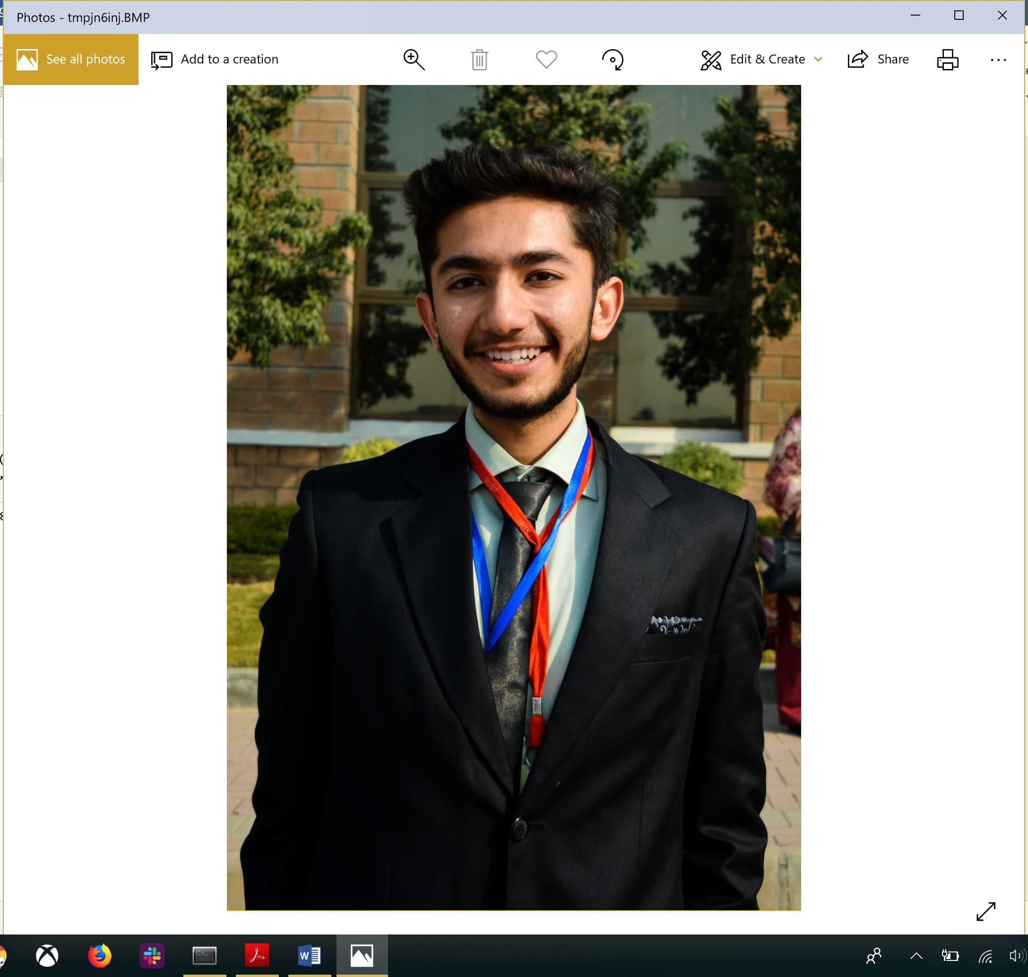

**Convert files to JPEG:**

import os, sys

from PIL import Image

images= ['Capture1.jpg','Capture.jpg','tempimg.jpg','catroon2.png']

for infile in images:

f, e = os.path.splitext(infile)

outfile = f + ".jpg"

if infile != outfile:

try:

Image.open(infile).save(outfile)

except IOError:

print "cannot convert", infile

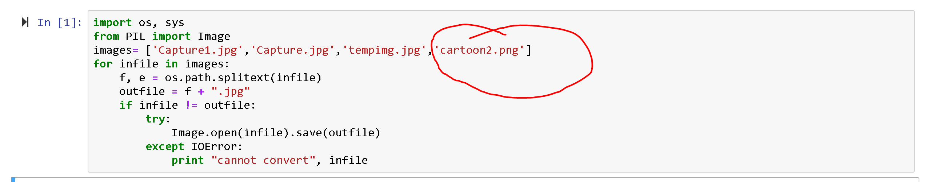

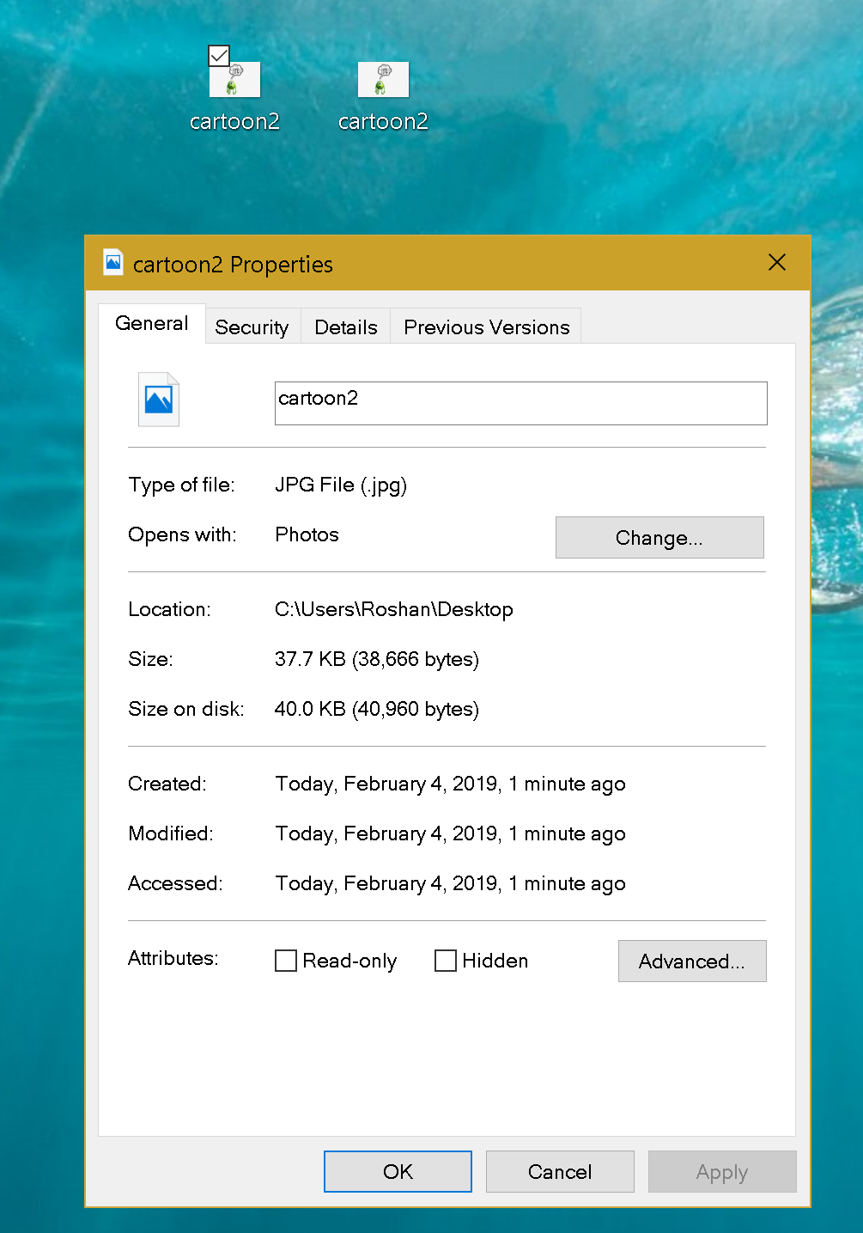

Task 3:

1. **Convert RGB to Greyscale**

from PIL import Image

img = Image.open('pp.png').convert('LA')

img.save('greyscale.png')



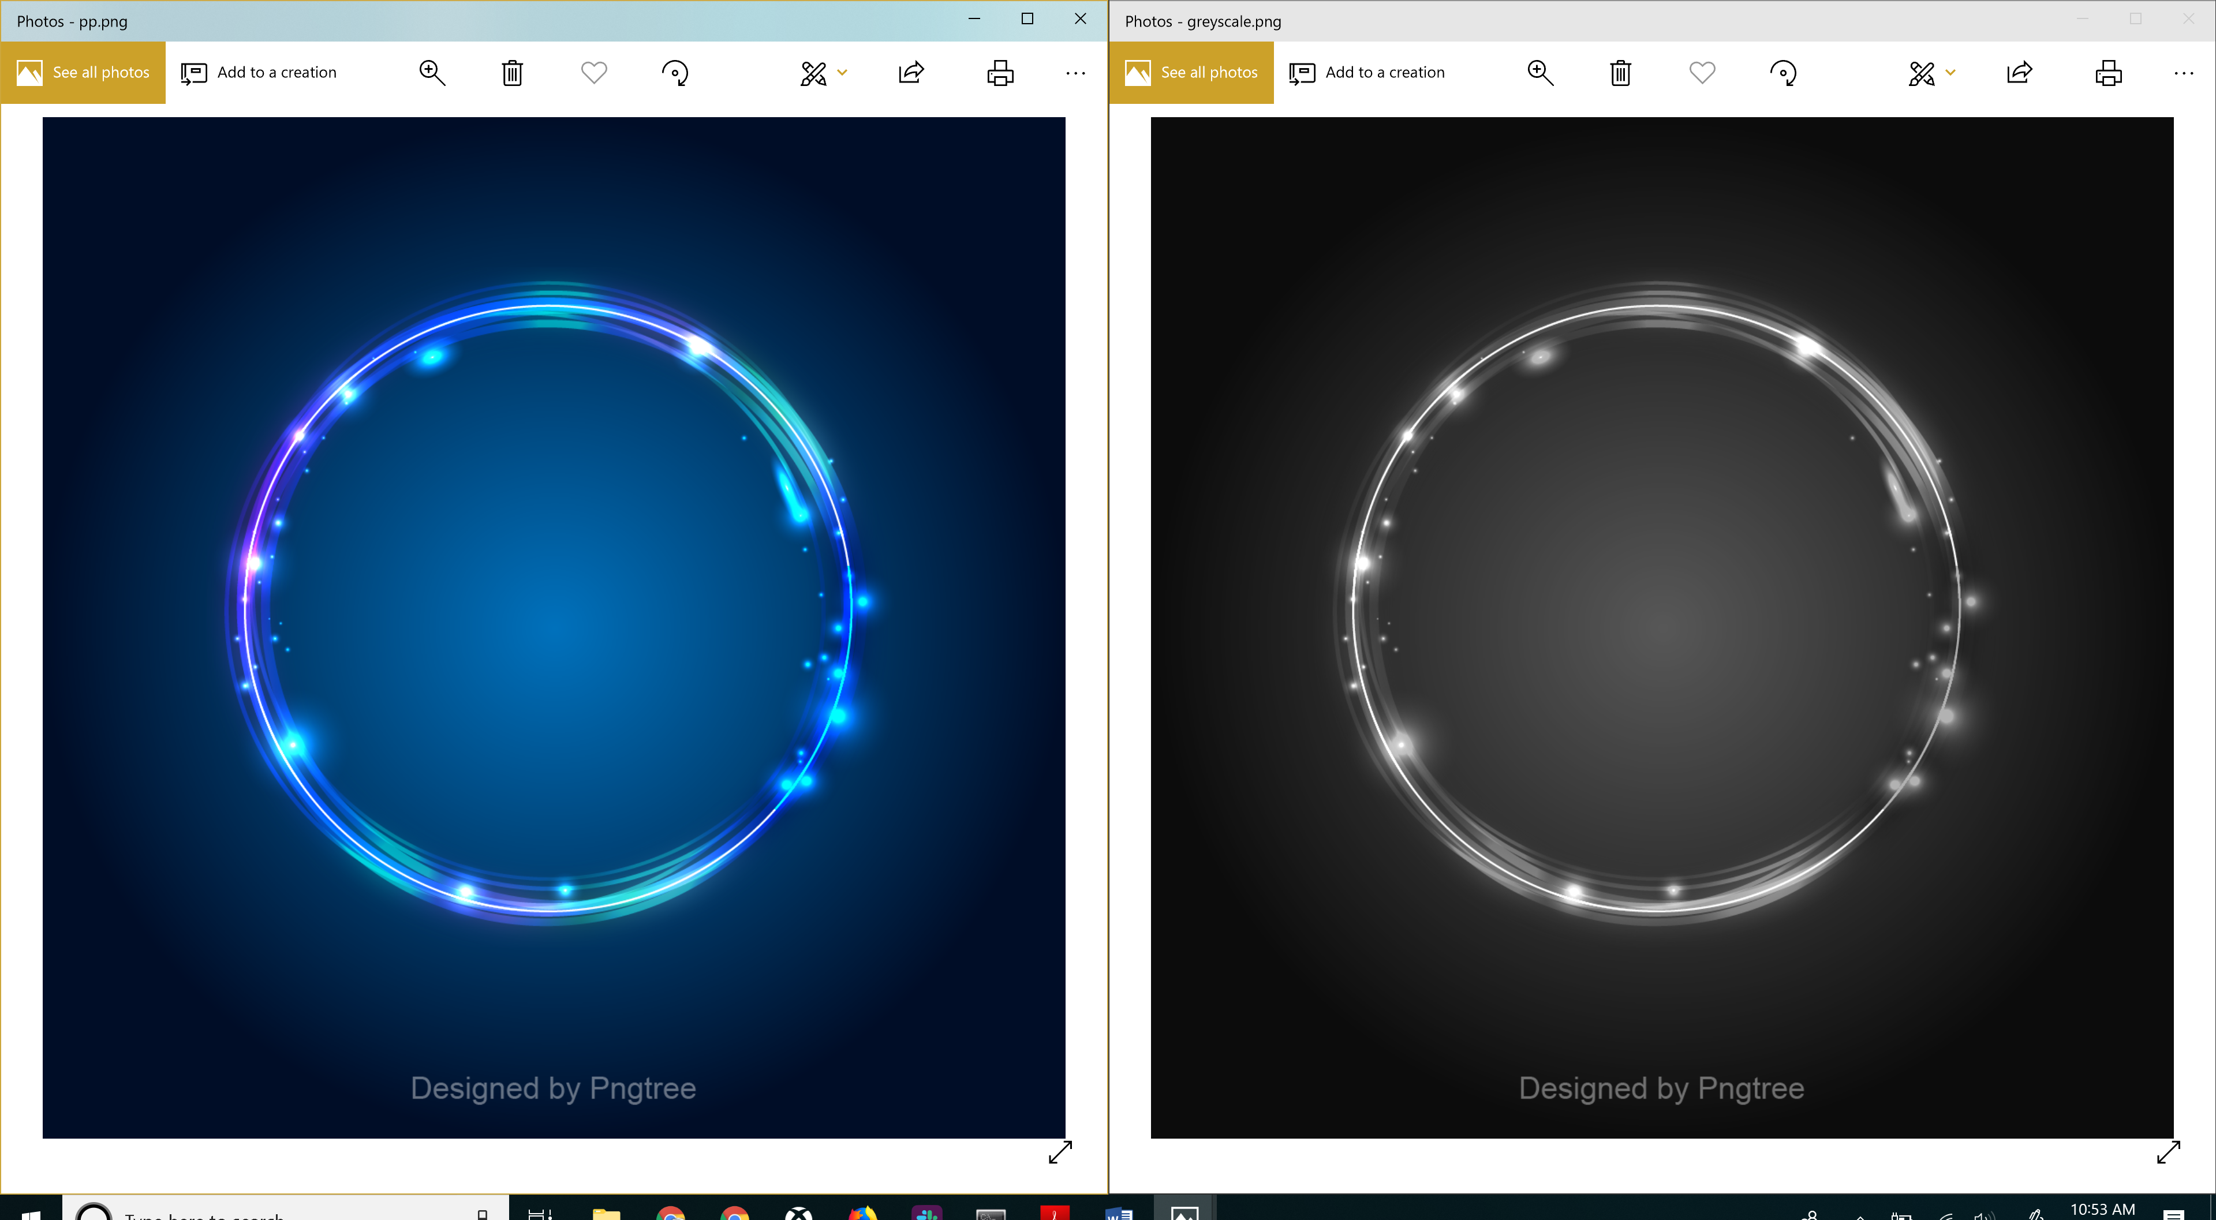

1. **Apply Smoothing filter:**

from PIL import ImageFilter, Image

im = Image.open("tempimg.jpg")

im1 = im.filter(ImageFilter.BLUR)

im1.show()

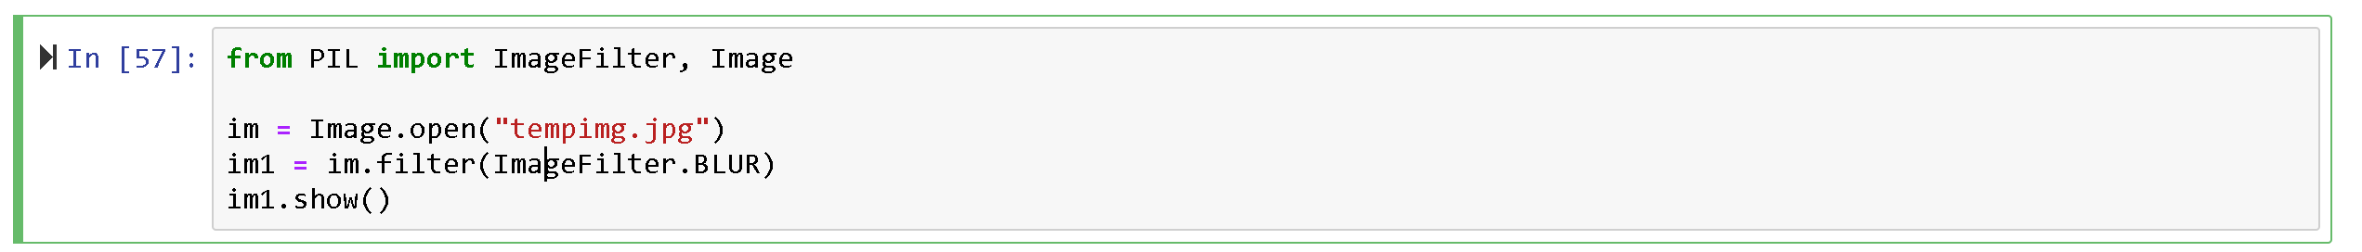

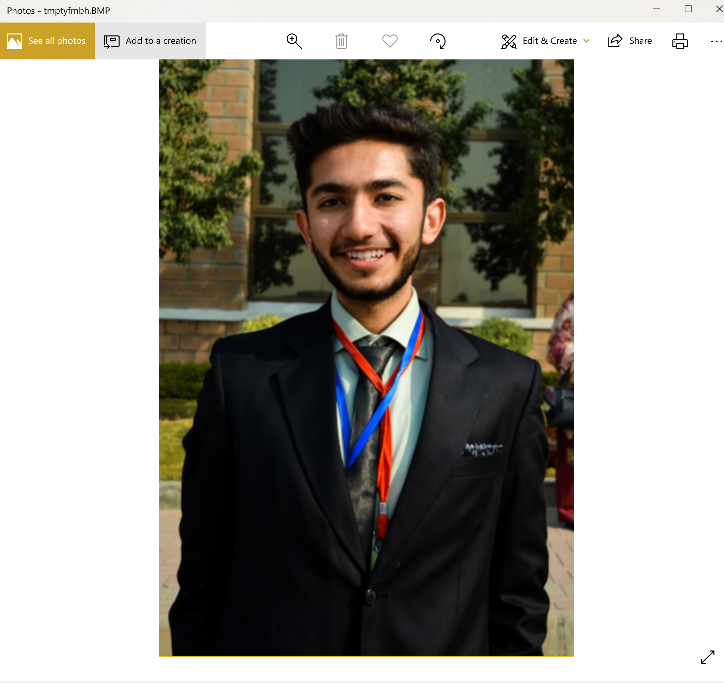

1. **Apply Sharpening filter :**

from PIL import ImageFilter, Image

im = Image.open("tempimg.jpg")

im1 = im.filter(ImageFilter.SHARPEN)

im1.show()

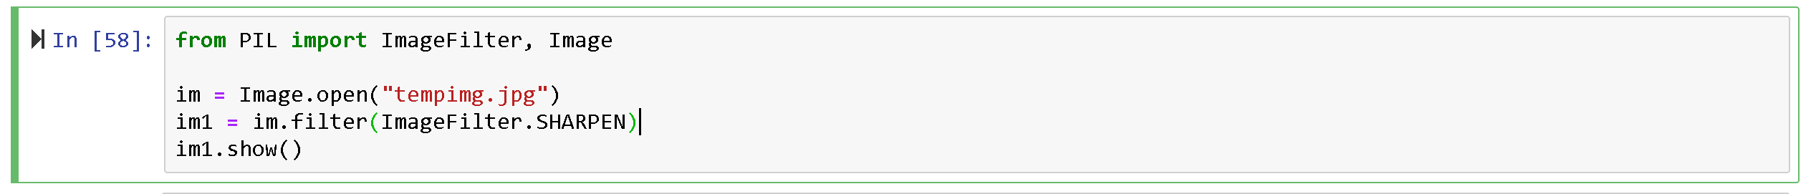

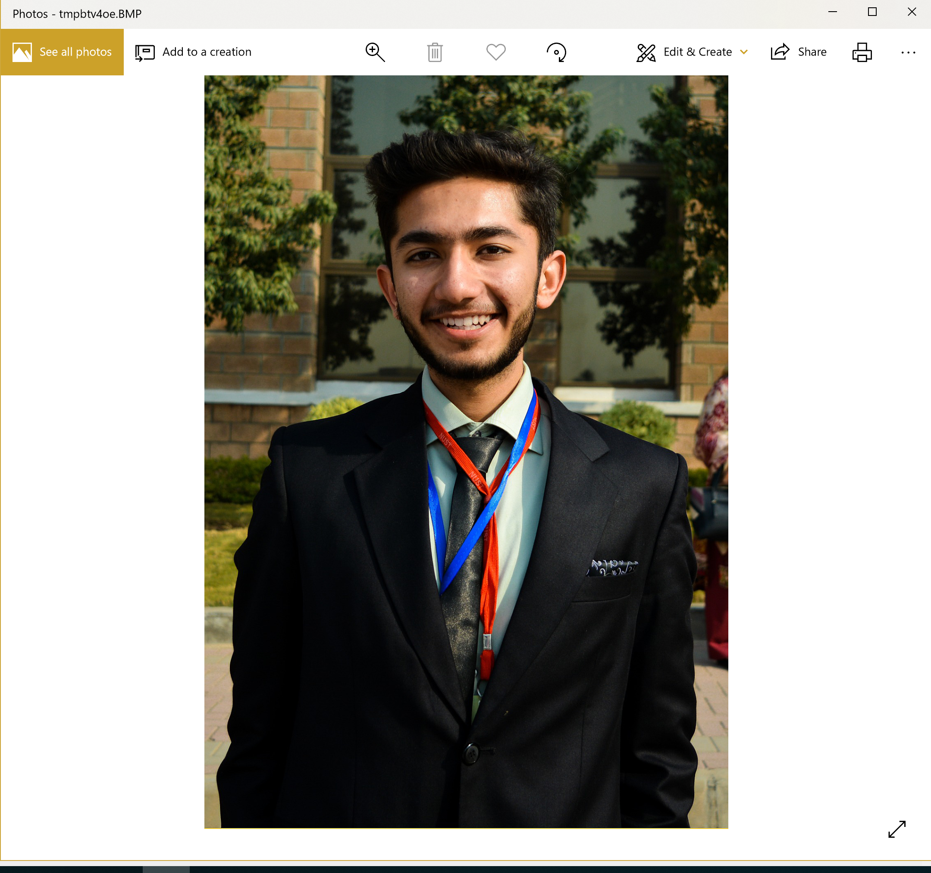

1. **Convert an RGB image to Greyscale**
2. import numpy as np
3. import matplotlib.pyplot as plt
4. import matplotlib.image as mpimg
5. def rgb_to_gray(img):
6. grayImage = np.zeros(img.shape)
7. R = np.array(img[:, :, 0])
8. G = np.array(img[:, :, 1])
9. B = np.array(img[:, :, 2])
10. R = (R *.299)
11. G = (G *.587)
12. B = (B *.114)
13. Avg = (R+G+B)
14. grayImage = img
15. for i in range(3):
16. grayImage[:,:,i] = Avg
17. return grayImage
18. image = mpimg.imread("pp.png")
19. grayImage = rgb_to_gray(image)
20. type(grayImage)
21. plt.imshow(grayImage)
22. plt.show()

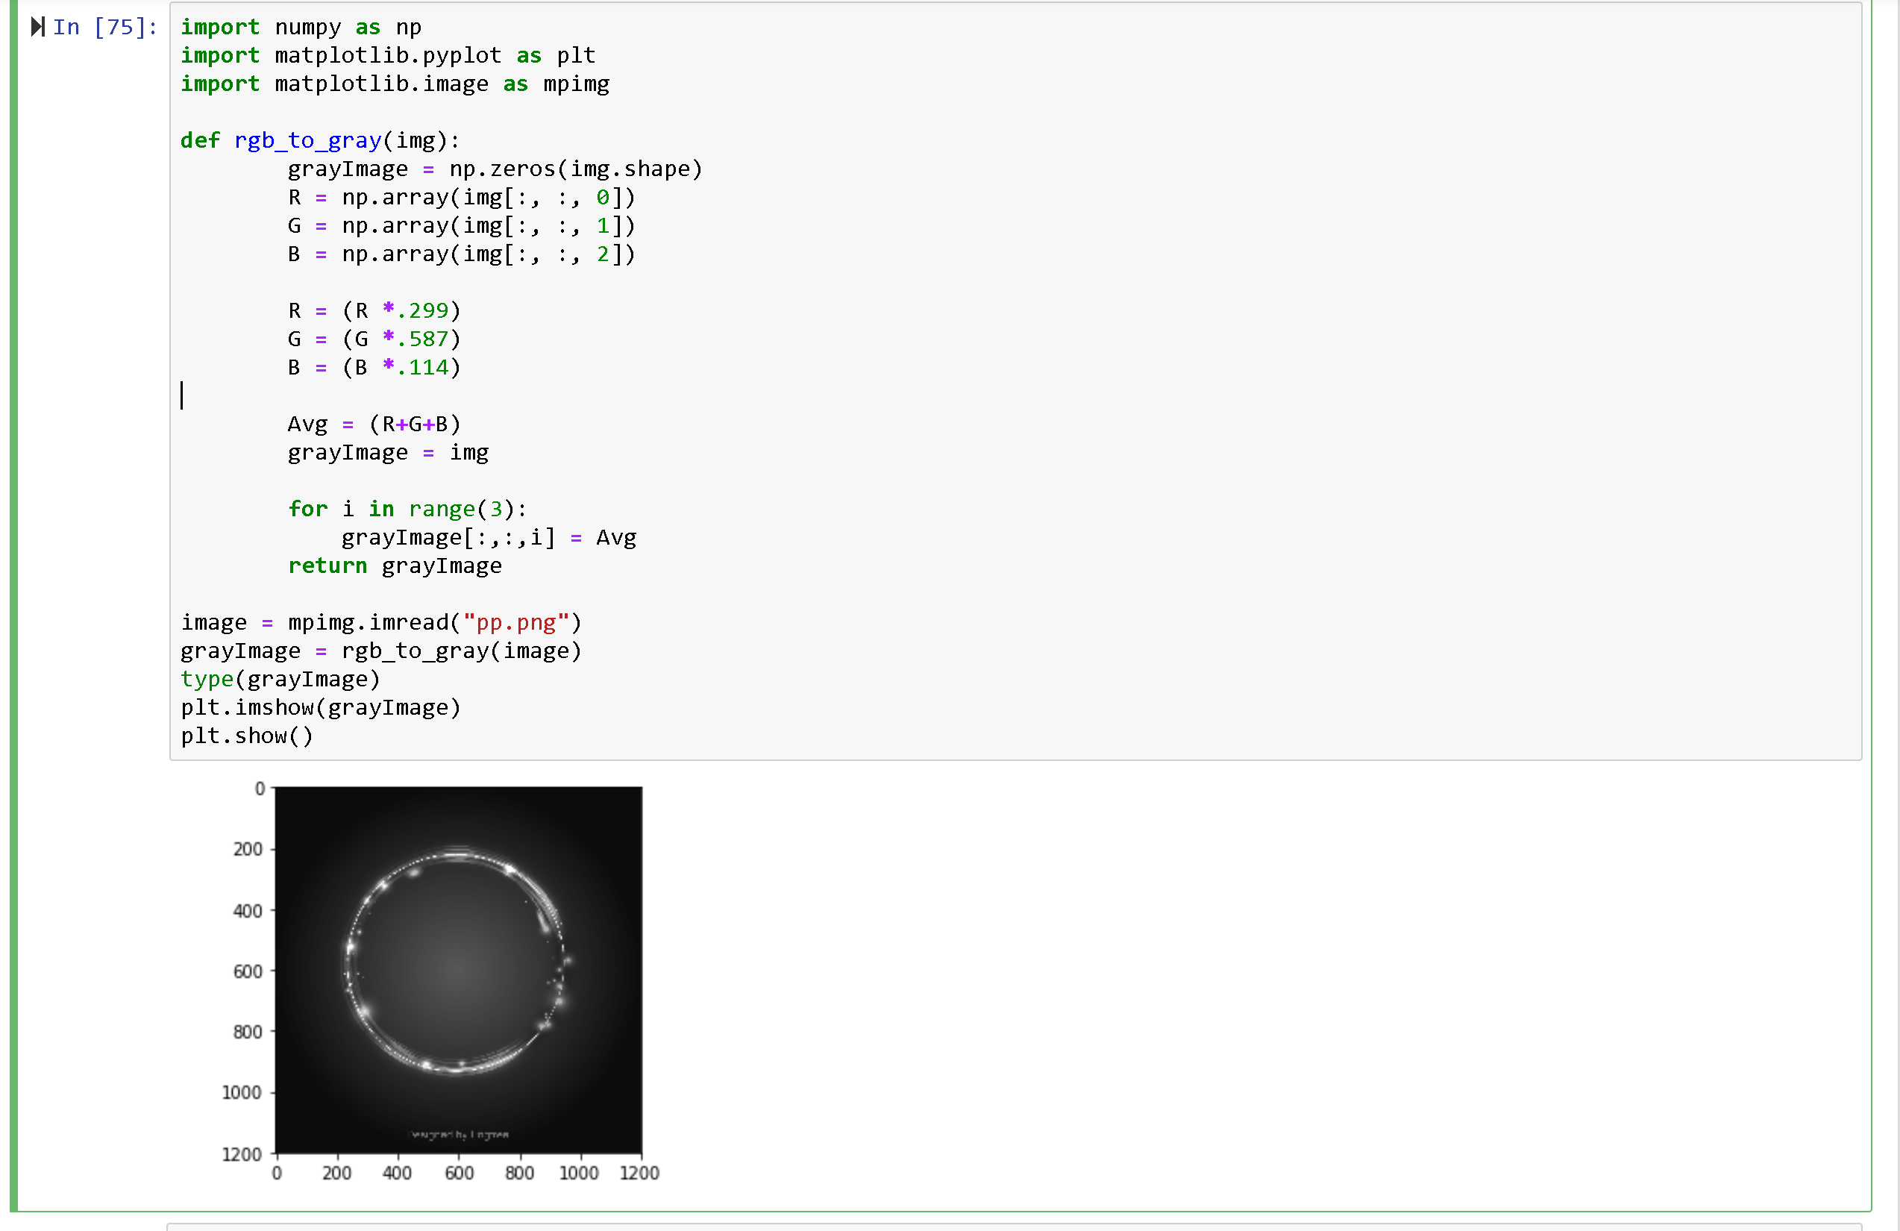

**HomeTask:**

from matplotlib import pyplot as plt

gray_image = cv2.imread("pp.png", cv2.IMREAD_GRAYSCALE)

plt.hist(gray_image .ravel(), bins=150)

plt.show()

